浙江省2010年初中毕业生学业考试（义乌市卷）
英语试题卷
考生须知：
- 全卷共8页，7大题，77小题。满分为120分，考试时间100分钟。
- 本卷答案必须做在答题纸的对应位置上，做在试题卷上无效。
- 请考生将姓名、准考证号填写在答题纸的对应位置上。并认真核准条形码上的姓名、准考证号。
温馨提示：请仔细审题，细心答题，相信你一定会有出色的表现！
试卷I
说明：本卷共有4大题，55小题，共80分。请用2B铅笔在“答题纸”上将你认为正确的选项对应的小方框涂黑、涂满，
- 一、听力（本题有15小题；第一节每小题1分，第二.第三每小题2分，共25分）
第一节：听小对话，请从A.B.C三个选项中选择符合对话内容的图片。
- What does the girl like?
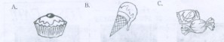
2. What is the weather like today？
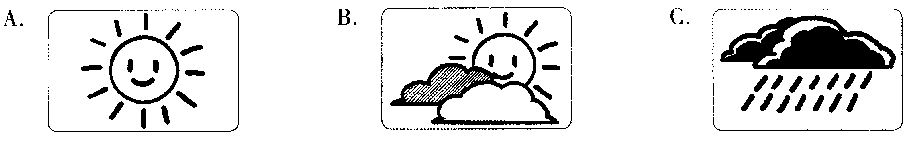
3、Which sport does Tom like best？
A.  B. 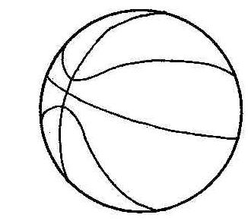 C. 
4、How did Mary come to Yiwu？
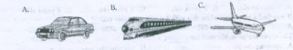
5、Where does the dialogue probably take place？
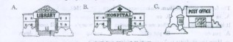
第二节：听长对话，请从A.B.C三个选项中选择正确的选项。
听下面一段较长的对话，回答第6~7两小题。
6. What is the woman going to do？
A. To have dinner. B、To give lessons C、To post a letter
7/. What’s the probable relationship between the two speaker？
A. Strangers B. Husband and wife C. Mother and son
听下面一段较长的对话，回答第8~10三小题。
8. What are the two speakers talking about ?
A. A camera B. An MP4 C. A mobile phone
9.How much does it cost ?
A. ￥400 B. ￥500 C. ￥600
10.Why did Mother buy it for the boy?
A. Because it was his birthday
B. Because he helped his mother do the housework
C. Because he got the first place in the English competition
第三节：听独白，请从A.B.C三个选项中选择正确的选项，完成信息记录表。
Summer Camp
Where to do： 11 How long to stay: 12 days
Who to go with: 13 When to leave:on 14 July
What to do:learn English and 15

11. A. England B. Australia C. American
12. A .12 B.14 C. .20
13. A. Miss Wang B. Miss Li C. Miss Zhang
14. A. 2nd B.5th C. 12th
15. A. go sightseeing B. go boating C. go fishing
二.单项选择（本题10小题；每小题1分，共10分）
请从A.B.C.D四个选项中选出可以填入空白处的最佳选项
16.— Mike，could you come and give me hand?
— OK，Mum. I’m coming now.
A. a B. an C the .D 不填
17. .—The land in the southwest of China is in great need of .
—Yes ,it hasn’t rained for a long time there.
A. milk B.tea C coffee .D water
18 .The famous writer Willian Shakepeare was born 1564.
- in B. on C at .D of
19 It is a good habit for us that we should never today’s work till tomorrow.
A put on B. put off C put up .D put down
20 --- Have the students in Yushu returned to school yet？
---It is reported on TV that .
- the weather is becoming better B. most of the factories were destroyed
C people have given lots of money to them .D all the schools have started lessons again
21 -- do you read English newspapers？
--I read 21st Century every day.
A How long B How often C How many .D How much
22 It to drive after drinking wine.
A. is allowed B. is not allowed C is made . D is welcomed
23. Zhou Yang is skating. She won a gold medal at the 2010 Olympic Winter Games.
A good at B weak in C tired of D angry with
24. –China beat Australia 1:0 at the 17th Women’s Football Asian Cup last night.
--Really？
A That’s a pity. B Don’t mention it
C I’m glad to hear that D You’re welcome
25 What would the mascot（吉祥物）of the World Expo 2010 Shanghai probably say in the picture on the right？

A Running can keep you healthy
B Welcome to Shanghai，China
C Animals are our good friend
D Water is very important for all of us
三. 完形填空（本题有15小题，每小题1分，共15分）
阅读下面短文，掌握大意。然后从A.B.C.D四个选项中选出最佳选项
I was waiting for the bus when I met the woman. “You look 26 . Come and sit here,” she said. “ 27 are you going?”
“I don’t know.I just want to catch a 28 and see what it will be like at the end.”
“I’m afraid you’ll see 29 there. Why don’t you enjoy the sights on the way?”
“How can I do that while my heart’s 30 ?” I asked sadly. My best friend had left me.
The woman seemed to understand my feeling. “Don’t cry, little girl. I’ve had a similar experience to you. Thirty-five 31 ago, my husband left our three children and me. I was deadly sad. I decided to kill myself and the children, so I took 32 to the sea. 33 ，they seemed to know what would happen, so they 34 loudly. Their cry suddenly woke me 35 . How could I 36 my hope to live for one of life’s problems? After that, I worked hard to raise the children. Now they all live 37 and one of them has his own family.
Then the woman gave me a 38 , “We should never wait for the door to 39 before us. We should find the key to the 40 or try to find another way”
The bus came and I got on it with a smile
26. A. tired | B. excited | C. happy | D. well
27. A. What | B.How | C. Where | D. When
28. A.train | B. bus | C. boat | D. plane
29. A. nothing | B.everything | C.something | D. anything
30. A. smiling | B.breaking | C. singing | D. dancing
31. A. days | B. weeks | C.months | D. years
32. A.her | B.them | C. him | D. it
33. A.So | B. Or | C. Besides | D. However
34. A. laughed | B.talked | C. spoke | D. cried
35. A. in | B. out | C. up | D. down
37. A. give away | B. give up | C.get up | D. stand up
37. A. happily | B. sadly | C.badly | D. hopeless
38. A. cry | B. shout | C. hit | D. smile
39. A. open | B. close | C. lock | D. mend
40. A. classroom | B. office | C. door | D. shop
四．阅读理解（本题有15小题，每小题2分，共30分）
阅读下面短文，从每题所给的A.B.C.D四个选项中选出最佳选项
A
  LOST ON MARch 8 NEAR MAN  STREET. BLACHE IS 8 YEARS OLD,BUT HE LOOKS YOUNG .  HE’S BLACK AND WHITE WITH LONG EARS.REWARD FOR INPORMATION  CALL SAM,598-3985 | 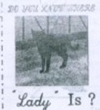  Lady is a black cat—only 6 months old. Her mother misses her！If you know where lady is,  CALL ANN,303-2720 | 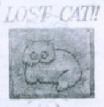  Help me find my pet cat！She is 6 years old. She has long white hair and a long tail. Her name is Snowball  Call Mark at 630-4789
41. How old is “lady”？
A.6 months old B.3 years old C.6 years old D.8 years old
42. if you find a black and white dog with long ears, please call .
A.630-4789 B.598-3985 C.303-2720 D.725-6982
43.The above are probably used for .
A. showing the pets B. teaching the pets
C. looking for lost pets D. asking for the way
B
My name is woof. You think that we have a great life，right？Wrong！I am going to tell you why.
First of all，we are bored. Bored. bored. And bored. Do you ever think about what a dog does all day？ Nothing. Nothing at all. Our owners are busy，you know，working，going to school，away from home all day. So what are we supposed to do？Watch the house or apartment？Sure. That is like watching paint dry or grass grow. Boring. That’s why we get so excited when our owners come home. We bark and run around and act as if we are very happy. But we only do this because we are bored all day. If we are lucky，our owner take us for a walk.
Then there is the food. We eat the same food，meal after meal，day after day，week after week，month after month. Help！Would you like to eat the same thing all the time？No，you would not. So what makes you think we dogs like it？We don’t. We hate it.
Another thing-television. Another thing-television. Dogs hate television. Our owners watch these stupid programs，hour after hour，night after night. Are there any programs for dogs on television？No. Not a single one.
So what can we do？What else can we do but sleep？And so we sleep. We dogs are not lazy，we are bored.
44. Woof may be a .
A. boy B. girl C.dog D.cat
45. From the passage，we know that Woof .
A. lives a great life B. is busy every day
C. likes the food very much D. hates watching television
46. How many points does Woof complain about？
A.1 B. 2 C.3 D.4
C
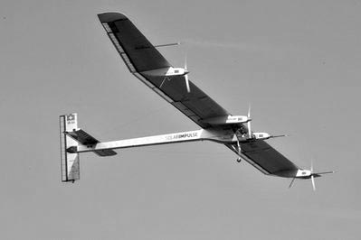
Recently，a solar powered（太阳能动力的）plane took to the sky for the first time. It had passed an important test on the way to travel around the world.
The plane took off from an airport in Switzerland（瑞士）at 45km an hour. It slowly rose above the fields and into the sky.
“There has never been an airplane of that kind that could fly — never an airplane so big, so light, using so little energy,” said Bertrand Piccard, a leader of the project.
During the 90-minute flight, the plane did several turns. It climbed nearly 1.6km above the countryside.
Engineers plan to test a night flight before July. Then they will use the results of the tests to build a second plane. They plan to travel around the world in that plane in 2012.
The plane flies at 70 km an hour. That is faster than a bike and slower than a car. Piccard and pilot Andre Borschberg will take the plane around the world. The pilots will keep the plane in the air for up to five days at a time.
“We want to fly it day and night with no fuel (燃料),” Piccard said
47. How long did the first flight of the solar powered plane last？
A. 45 minutes B. 60 minutes C. 70 minutes D. 90 minutes
48.What’s the most special about the plane？
A. It uses no fuel B. It’s the fastest plane
C. It can fly highest D. It’s the heaviest plane
49. Which of the following is NOT true according to the passage ?
A The plane goes much faster than a car
B The plane took off at a speed of 45km an hour
C Engineers plan to test a night flight before July
D The plane will fly in the air or up to five days at a time
50.Which column（栏目）of a newspaper may the passage come from？
A. Food and Health B. Scientist and Technology
C. Culture and Communication D. Sports and Entertainment
D
Different countries have different customs. When you travel to another countries，please follow their customs，just as the saying goes，“ .”
Very often people who travel to the United States forget to tip（付小费）.It is usual to tip porters who help carry your bags，taxi drivers and waiters. Waiters expect to get a 15% tip on the cost of your meal. Taxi drivers expect about the same amount.
In England，make sure to stand in line even if there are only two of you. It’s important to respect lines there. It’s a good idea to talk about the weather. It’s a favourite subject of conversation with the British.
In Spain，it’s a good idea to have a light meal in the afternoon if someone invites you for dinner. People have dinner very late，and restaurants do not generally open until after 9 pm.
In Arab countries，men kiss one another on the cheek（脸颊）. Your host may welcome you with a kiss on both cheeks. It is polite for you to do the same.
In Japan，people usually give personal or business cards to each other when they meet for the first time. When a person gives you a card，don’t put it into your pocket right away. The person expects you to read it.
Don’t forget to be careful of your body language to express something In conversation. A kind of body language that is acceptable in one culture may be impolite in another.
51. When you travel to the USA，you don’t need to tip .
A. porters B. waiters C. 70 minutes D. 90 minutes
52.The missing sentence in the first paragragh should be“ .”
A. Love me，love my dog
B. He who laughs last laughs best
C. When in Rome，do as the Romans do
D. Where there is a will，there is a way
53.The underline word“porters”in the passage means .
A. 搬运工 B.清洁工 C.接线员 D. 售票员
54. Which of the following is TRUE according to the passage ?
A. In Spain，People usually have dinner very early
B. In England，It’s a not polite to talk about the weather
C. In Arab countries，men kiss one another on the cheek
D. In Japan you should not read the business card as soon as you get it.
55. What，s the best title of the passage ？
A. How to Tip B Body Language
C When to Have Dinner D Advice to International Travellers
试卷II
说明：本卷共有3大题，22小题，共40分。大题请用0.5毫米及以上的黑色签字笔书写在“答题纸”的对应位置上。
五、词汇运用（本题有15小题；每小题1分，共15分）
A．根据短文内容和所给汉语提示，写出短文空白处各单词的正确形式。每空限填一词。
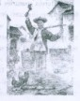
Chen Huan：Glad to meet you，Mr Zhu. Welcome to Yiwu TV Station to tell your 56
（故事）of doing business.
Mr Zhu： Thank you. I’d like to say something that happened thirty years ago.
Chen Huan：At that time，you didn’t have 57 （足够的）ood to eat.
Mr Zhu：Right. So I 58 （去）out to do business to make money by exchange
sweets for chicken feathers，old shoes and so on.I had to get up very 59
（早）every morning and travel a long way on 60 （脚）.
Chen Huan：It must be a special experience for you.
Mr Zhu：Yes. During that time，I was’ often tired and hungry 61 （没有）anything
to eat.，especially on those 62 （寒冷的）winter nights…dut now
everything is better. I own a big factory with hundreds of 63 （工人）.
And I can 64 （卖）my products to the world in a modern market. I’m sure my
business will be better and better in the future.
Chen Huan：How moving! Hard work makes a successful businessman. You’re really a great
example for the 65 （年轻的）people in Yiwu.
B.用方框中所给的单词的适当形式填空，每个单词限用一次。

Busy swim hardly three ourselves
66. Father’s day is on the __________Sunday in June.
67. The traffic during the rush hour is much __________than usual
68. We must learn to look after __________ when we are alone at home.
69. _________is good or our healh.
70. When I got to the op of the high mountain，I could__________walk any more.
六、任务型阅读（本题有5小题；每小题1分，共5分）
中学生上网一直是备受关注的热点话题。某班就这一话题组织了一次主题班会。以下是几位同学的观点，请仔细阅读下面内容，完成信息记录卡。
Li Hua：Surfing the Internet is very exciting. We can do lots of things，such as playing games，listening
to music，chatting with our friends and so on. I really enjoy it.
Wang Gang：I like surfing the Internet，too. Because I can learn a lot from it. I can get the latest news
all over the world. I also can find the information I need so that I can spend less time on my
homework
Zhang Jie：It’s hard to say. I agree that the Internet is helpgul to our study. But it’s not right to spend too
much time on the games. And some information on the Internet is bad for our mind. What’s
more，surfing too much does harm to our eyes. In a word，we should use the Internet in a
right way.
Names | Opinions
Li Hua | ◇play games  ◇listen to music  ◇chat with 71
Wang Gang | ◇get the lastest news  ◇get useful 72  ◇do homework 73
Zhang Jie | ◇be helpful to our study  ◇don’t spend too much time on the games.  ◇be bad for our mind and 74  ◇use the Internet 75
71. ____▲______ 72. ____▲_____ 73. ____▲______ 74. ____▲______
七、书面表达（本题有2小题；76题5分，77题15分，共20分）
76.你即将告别朝夕相处的初中老师，请选择5门学科，给这些老师分别写一句最想对她/他说的话。下面所列学科供参考。
注意：范例可以适当参考，但不得抄袭；句中不得出现真实的人名和校名.
English Chinese Maths Science PE Art Music IT….
e.g. My dear English teacher，your class is really interesting.
▲
▲
▲
▲
▲
77.请你选择最喜欢的一门学科，以My favourite Subject 为题，写一篇短文，说说喜欢这门学科的理由，以及平时是怎样学习的。
要求：1.词数80左右
2.叙事清楚，语句通顺，语意连贯。
3.文中不得出现真实的人名与校名。



