2011年牡丹江市初中毕业学业考试
英语试卷
考生注意：
1.•考试时阆120分钟
2.全卷共六道大题.总分120分[来源:学,科,网Z,X,X,K]
3.所有试题请在答题卡上作答，在试卷上答题无效

第一部分听力理解（共计25分）
I. Listening (本题共 25 分，Part One、Part Two 每小题分，Part Three、Part Four 每小题2分）
Part One Choose the right picture according to the description you hear.
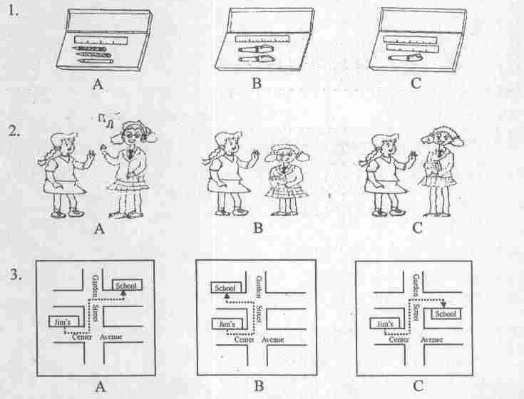
Part Two Match the best choice from A to F according to what you hear.
4. Lingling A. joins the stamp collectors’ club.
5. Henry B. is more interested in basketball.
6. David C. is a tennis fan.
7. Xiaoming D. likes rock music very much.
E. wants to know more about China.
F. doesn't like Li Na at all.
Part Three Choose the right answer according to what you hear.
8. _____ show the greatest interest in the film.
A. Adults B. Children C. Old people
9. The film and the TV series have the same _______
A. ending B. characters C. story
10. It's _______to buy tickets for the film.
A. easy B. difficult C. impossible
11. The box office (泉历 J of the 151m has reached _______yuan.
A. 3,000,000 B‘ 13,000,000 C. 30,000,000
Part Four Complete the chart according to what you hear.
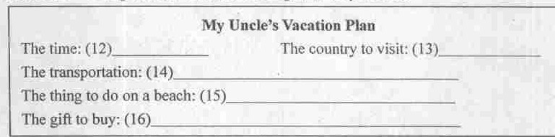
第二部分语言知识运用（共计45分）
IL Multiple choice (本题共15分，每小题1分）
Choose the best answer from A, B or C according to the meaning of the sentence*
17. Lily will go to the _______. She wants to exchange some money in it
A. bank B. restaurant C. bookstore
18. Alice, are you ready? We'll go out for a picnic _______nine o'clock.
A. in B. after C. until
19. —Sugar or milk in your coffee?
—Sugar. I like coffee with _______in it.[来源:Zxxk.Com]
A. nothing sweet B. something sweet C. something sour
20. —Did Miss King see your report card?
—Yes, she did. The smile on her face showed she was very _______.
A. upset B. worried C. pleased
21.It has rained for almost a month in Mudanjiang. We ______saw the sun come out.
A. often B. hardly C. always
22. —We'd better not eat too much junk food ______ it is delicious.
—I agree. It's bad for our health.
A. if B. although C. because
23. The birthday cake ______ good. We all can't wait to eat it
A. sounds B. tastes C. smells
24. __________ skirt you bought yesterday! —Thank you.
A. What nice B. How nice C. What a nice
25. The Palace Museum is the best place _______I've ever visited. There are many old things in it
A. who B. that C. where
26. —Sally and Rose _______about the TV show yesterday.
—Let's join them quickly.
A. talk. B. talked C. are talking
11. —I want to know if you mind my sitting here.
—________. It's for Mr. Brown.
A. Of course not B. Belter not C. Never mind
28. —I hear that a new park _______in the center of the city by 2012.
—That's great
A. will build B. will be built C. was built
29. —Hey! Don't you remember me?
—Wow! Mary? You _______ curly hair. But now you have straight hair.
A. used to have B. were used to have C. are used to having
30. —Could you tell me _______ to see me next week?
—I'm not sure. If I'm free, I will.
A. if you will come B. how you will come C. whether you would come
31. Which sign is made for safety?
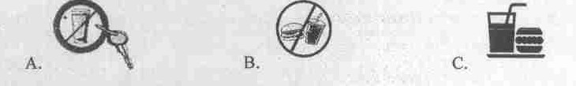
III. Cloze test (本题共15分，每小题1分)
Choose the best answer to complete the passage.
You've just finished with middle school and you may start wondering, “What is high school like? Is high school a lot 32 middle school? Is it going to be hard to start out in a new place?"
Most high schools in America hold a freshman class 33 school actually starts. When you talk to people in the freshman class, you 34 that a lot of them are feeling just like you are, excited, maybe 35 afraid. Talking about a question of common interest with your classmates could start a new 36 .
The work in high school builds on what you 37 in middle school, and gives you more knowledge of many subjects. So you 38 feel that it's a bit more challenging. But these challenges can make you feel 39 . And there are many resources (资源）to use if you feel that the work is too much.
At the beginning of high school, you'll get to know it has more activities than middle school, such as clubs, music groups, and sports teams. These activities may 40 before or after school, or during your free time. 41 this, time management is an important skill in your 42 year.[来源:Z#xx#k.Com]
Middle school teaches you the 43 of study and social skills while high school gives you the chance to learn 44 to be more independent (独立的).It's all right if you're nervous 45 . Just be patient and keep 46 . Once you've got used to your new independence, you can go farther than you ever imagined.
32. A. the same as B. different from C. helpful to
33. A. before B. after C. since
34. A. found B. will find C. have found
35. A. too B. so C. a little
36. A. hobby B. friendship C. topic
37. A. are learning B. will learn C. have learned
38. A. have to B. should C. may
39. A. more bored B. less bored C. less excited
40. A. take part B. take up C. take place
41. A. Because of B. Thanks to C. Instead of
42. A. first B. second C. third
43. A. aims B. pleasure C. ways
44. A. what B. how C. whether
45. A. at first B. at last C. at that moment
46. A. doing B. studying C. trying

IV. Communication (本题共IS分，A题每小题1分，B题每小题2分)
(A) Choose the best response from A to G in the box to complete the dialogue. Each choice should be used only once.
Tom: Excuse me. I'm from our school newspaper. My classmates and I would like to interview some students. Can I ask you a few personal questions?
Emily: Um …
Tom: (47) _________. They're not too difficult!
Emily: OK. What would you like to know?
Tom: Well, what does it feel like to be at school in China?
Emily: It's great! (48) ___.But people here are friendly, so 1 am never alone any more!
Tom: What do you think is the most difficult thing for a foreigner living in China?
Emily: (49) ________. I'm learning it now, but it's going to take a long time.
Tom: (50) _____________
Emily: My parents. But they’re coming over to visit me in a few months.
Tom: OK! Thank you!
Emily: (51) ____________.
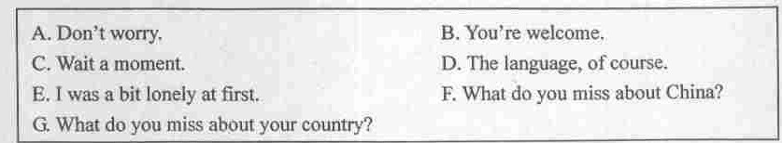

(B) Complete the dialogue with proper words or sentences.
A: Hi, Cathy! You look excited. (52)._______？
B: I'm going to spend my summer vacation in Hong Kong. I'll visit Disneyland. My dream to meet Mickey Mouse and Donald Duck will come true.
A: (53). ？
B: No, with my parents. We'll fly there as soon as the final examinations finish.
A: That's great! If you go to Hong Kong, (54)_______. Hong Kong is
a shopping paradise (购物天堂).The things there are more fashionable.
B: Of course I won't But maybe my mother will be more interested in it I prefer eating to shopping.
A:(55) ？
B: Seafood is my favorite. I also like different kinds of desserts.
A: If so, Hong Kong will be suitable for you. There are many kinds of delicious food you can enjoy. (56).____________.
B: Thanks. See you!
第三部分阅读理解（共计35分）
V. Reading comprehension (本题共³⁵分，A、B、C题每小题1分, D, E题每小题²分)
(A)
A. Entertainment News
In this section all kinds of news about movies, songs and pop stars are available (可找到的).
B. Advertisement Section
Here are advertisements of different products, such as food, latest books, and sporls machines, etc.
C. Reading Section
In this part, we will introduce some hot traveling places to you. Some safety tips during journeys are also offered.
D. International News
Here is news about the events that happened all over the world.
E. Sports News
Important sports events are broadcast (传播)here. And we often interview some good players.
F. Health Section
Winter is coming and it is easy to get ill. If you want to know how to keep away from diseases, you should pay attention to this section.
Match the information according to what you read.
57. Mike cares about sports events and how the sports players are now.
58. Mr. Brown is interested in reading. He wants to know what kinds of new books have come out and where to buy them.
59. Zhang Peng is really a film fan. Recently he would like to know what new movies are like and some information about Jackie Chan.
60. Lana's father is working abroad (国外）in Libya. A war (战争）broke out there, so she is rather worried about the situation in Libya.
61. Lucy is in poor health. She is so anxious to know how to keep fit.

(B)
Some people like to get up late, but some do not. In fact, it is really good for us to get up early every day. Maybe those who don't like getting up early will not believe this, but it is true.
Scientists made a survey in about one thousand people, and then they found that early rising people had less disease than late rising people, and early rising people also looked healthier than late rising people, and so on.
So we may know early rising is helpful in more than one way. First, it helps to keep us healthy. We all need fresh air. But air is never as fresh as early in the morning. Besides, it is useful to do morning exercises.
Secondly, early rising helps us in our studies. In the morning we learn more quickly and find it easier to understand what we learn.
Thirdly, early rising can give us a plan of our work for the day. We cannot work well without a good plan.
Fourthly, early rising gives us enough time to get ready for our work^ such as to wash our hands and faces and eat our breakfast.
Late risers may find it difficult to form the habit of early rising. They have to make an effort (努力）to do so. As the English proverb says, “Early to bed and early to rise makes a man healthy, wealthy and wise•”
Judge the following sentences true (T) or false (F) according to the passage.
62. People don't always agree on whether to e»et up early.
63. In the passage the writer gives four reasons for early rising.
64. Early rising makes people happier according to the passage.
65. Early risers don't look as healthy as late risers.
66. The writer encourages people not to sleep late.
(C)
Nick Petrella is a doctor in Montreal. He works 60 hours a week. He takes care of more than100 patients a week in the hospital and at his office. He's been a doctor for ten years.
Dr. Petrella offers lots of help to his patients. But he doesn't just tell his patients what to do.
He also sings to them on television! Dr. Petrella has his own TV show. The show is in Italian, English and French. The doctor starts the show with a song and then he explains a medical problem or disease in simple language. After that, he sings another song.
Dr. Petrella makes and performs in his own show every week. The program is very popular with his patients and with people who enjoy his singing. His dream is to perform in Las Vegas.
His favorite songs are love songs, and he has a CD of love songs that he wrote. Dr. Petrella says, “I always love to sing. All my problems are gone when I sing.” But when Dr. Petrella was young,
his father didn't want him to be a singer. So he went to a medical school.
Some people tell Dr. Petrella he can help people more as a doctor. But Dr. Petrella says he helps people when he sings, too. “1 like to make people smile. Sometimes it's difficult to make a sick person smile. Medicine and entertainment both try to do the same thing. They try to make people feel good . [来源:学科网ZXXK]
Choose the best choice from A, B or C according to the passage.
67. In his TV show, Dr. Petrella _________ .
A. sings love songs he wrote B. sings about different diseases
C. sings and explains a medical problem
68. isn't used in his TV show.
A. Russian B. English C. Italian
69. Dr. Petrella performs in his show 10_________.
A. become famous B. make people feel good C- achieve his dream
70. From the article, we can know Dr. Petrella is _____________.
A. talented and proud B, creative but lazy C. kind and helpful
71. What’s the best title (标题）of the article?
A. Medicine and Entertainment B. His Dream Came True C. A Singing Doctor
(D)
When I was leaving to meet Lynne, my friend Tony told me that I’d better take some money. But I didn't listen to him. I thought Lynne would pay because she had invited me. I arrived at the restaurant on time. I know Americans expect you to be on time. Lynne and I sat at a table and a waiter brought us some delicious food.
The dinner was a great success. We talked a lot while eating. After two hours, the waiter finally came and asked if we wanted one check (账单）or two, Lyrme said two. We went to the cashier and Lynne paid her check. I was embarrassed when the cashier gave me my bill. I had no money to pay for my meal. Then I had an idea. I said，“Oh! I forgot my wallet! Can I call my friend, please?" The cashier showed me where the phone was and I quickly called Tony. In a few minutes, he arrived with some money, and paid my check. He laughed at me all the way home. Now, I think it's funny too, but at that time I was very embarrassed. I thought an invitation to have dinner in America meant the same thing as that in China. Now 1 think you have to understand thai your customs are only your customs. When you visit a foreign country, you have to learn about their customs, too. They can be quite different.
Fill in the blanks according to the passage. Only one word for each blank.
One day I got an invitation to dinner from Lynne. Before I left, my friend Tony told me to take some money, bul 1 didn’t take his (72)______. 1 reached the restaurant on time because I know being late is thought to be (73)______ . Lynne and I enjoyed the dinner very much. But two hours (74)_______, 1 got into trouble (75)_______my check. I thought Lyrme would pay (76)________of the checks. In fact I was wrong. I had to call Tony for help. After the problem was solved, I realized the importance of learning about different customs.

(E)
Teachers say buying homework answers online is not many in schools, but an interview with school students shows only 10% are willing to finish their holiday homework by themselves.
Their main complaint is that the homework is too much for them to finish.
“As far as ！ know, many of my students have to go to all kinds of training classes during the holiday. These lake away much of their time for doing homework.”
But as for the parents who are sending their children to these training classes they also say they've got no choice. Here's a view from a student's father.
"All the other kids in the neighborhood are learning extra things. You know parents sometimes compare their kids. I'm afraid my kid will be less successful than the others in the future."
In order to do with this situation of students copying each other's homework, some schools have even dropped the idea of holiday homework. Instead, they organize some interesting outdoor activities.
Educational experts say students love to learn through games or activities that they can be a part of‘ They suggest schools drop the current (目前的）homework format (设计)，and turn to homework that encourages kids to get involved (参与).This way, they would no longer want to copy from each other or buy answers through the Internet.
Answer the following questions according to what you read.
77. Why do students copy or buy homework answers?
78. What do students spend much time on during the holiday?
79. Most parents want their kids to be successful, don't they?
80. How do some schools deal with the problem of students copying homework?
81. List a kind of your favorite holiday homework according to the passage.
第四部分书面表达（共计15分）
VL Writing <本题共15分，A题S分，B题10分）
(注意：文章中不能出现考生的真实姓名、校名和老师名，否则不给分)

(A)昨天下午Dick在篮球比赛中受伤，医生叮嘱他卧床休息，所以无法上学《请你以Dick的身份写一张病假条，向Mr. Green请两周的假》
(B)每个孩子成长的背后都离不幵母亲无私的爱，她们在每天工作之余，不但要操持家务,还要辅导孩子学习。作为孩子，我们将怎样报答她们的养育之恩呢？请以此为话题，谈谈母亲对你的爱以及你将如何孝敬母亲，同时表达对她的美好祝愿。
要求：1、写作思路清晰，语言表达准确、流畅。
2、字迹淸楚、工整，字数80~100词。



