岳阳市201 1年初中毕业学业考试试卷
英 语
1．听力技能(共四部分，20小短，每小题l分；共20分)
A)图片判断 根据你所听到的五段短对话．从A—G中选择五个与你所听对话内容相符的图片，并将代表图片的字母填在答题卡的相应位置．其中有两幅图片是多余的。
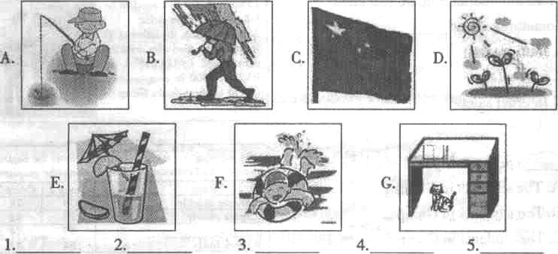
B)对话理解根据你所听到的对话内容．选择回答问题的最佳选项。
听下面一段对话．做第6、7小题。
6. How do the two speakers get the news?
A. On TV. B. On the radio. C. From the newspaper.
7. Who was badly hurt in the traffic accident?
A. A bike rider. B. A truck driver. C. A car driver.
听下面一段对话．做第8-10小题。
8. How many times will the movie be shown that night?
A. Twice. B. Three times. C. Four times.
9. Where is the man's office?
K. On the third floor. B. On the second floor. C. On the first floor.
10. How much is the ticket?
A. 30 yuan. B. 40 yuan. C. 50 yuan.
c)采访反应 根据你所听到的采访内客和实际情况，写出答语，完成录音问卷调查表。
QUESTIONAIRE
Yow subjects
11． 12．
13． 14．
15．

D)笔录要点 根据你所听到的短文，完成下列表格中第16-20小题（毎空不超过三个单词）。
Help to Fight Pollution
Pollution | Water | Making rivers and lakes dirty.  Killing fish and polluting our l6 water．
Pollution | Noise | Making us talk l7 and become angry more easily．
Pollution | 18． | Bad for living things.
 | Factories | 19．their water before throwing it away.
Rules | People | Do not throw waste on the ground  Go to work 20． or in the same car．

Ⅱ.知识运用(共两部分，共20小题．每小题1分；共20分)
A)单项填空 从A、B、C三个选项中选择一个最佳答案填空。
21. There a football match on CCTV-5 at nine tomorrow evening.
A. will have B. is going to be C. is having
27. Would you mind me how English words?
A. tell; to remember B. telling; remember C. telling; to remember
23. - Must I hand in my exercise book now, Mr. Zhao?
- No, you __. You may give it to me tomorrow.
A, needn't B. mustn’t C. can't
24. Your sister has bad cold, and you must give her some medicine __ this afternoon.
A. an; / B. a; / C./;the
25. It's from our school to my home.
A. ten minutes' walk B. ten minute's walk C. ten minutes walk
26. of the land is covered with trees and grass in Pingjiang, Yueyang.
A. Three fives B. Three fifths C. Three fifth
27, - The girl __all her pocket money to the people in the Southwest for the serious drought(旱灾).
- What a good girl!
A. took away B. gave up C. gave away
28. Every year lots of trees to make our country more beautiful.
A. is planted B. are planted C. plant
29.- May I go to the movies with you?
- I'm afraid not you have a ticket, because I have only one.
A． if B. unless C. though
30. I can't forget the time the earthquake happened in Yushu.
A. when B. which C. where
B)完形填空 通读全文，掌握其大意，然后从各题所给的A、B、C三个选项中选出一个最佳答案。
In many classrooms, it's not 31 to find students spinning (旋转) their pens 32they listen to their teachers.
Pen-spinning is also popular 33 Japanese students. It is a form of entertainment. Recently, a pen-spinning competition was held in Tokyo, Japan. Ryuki Omura, a 16-year-old high school student, became the first pen-spinning 34 .
276 people took part in the competition. The came from different age groups. Some were students 35 some were office workers. First, they 36 the videos of their pen-spinning skills to the organizer's website. Then some of them came to the last round in Tokyo. 37 of them had 30 seconds to show their skills in front of 400 people, 38 reporters and fans. Omura took a pen from his little finger to the rest fingers, then to his palm(手掌) and the back of his hand. His wonderful show made him 39 the champion.
Omura said he began learning pen-spinning only about 14 months ago. He did 40 in the competition. If you like to spin your pen, you can practice it in your spare time. But when you are in the class, please don't do that.
31. A. different B. easy C. common
3l. A. before B. when C. after
33. A. for B. between C. among
34. A. chairman B. captain C. champion
35. A. or B. and C. with
36. A. were sent B. sent C. was sent
37. A. each B. Both C. Every
38. includes B. included C. including
39. A. become B. became C. becomes
40. A. quite good B. quite well C. quite better
Ⅲ. 阅读技能(共五部分．25小翘每小题2分=共50分)
(A)
判断 阅读下面的材料，判断下列句子是否符合短文内容。符合的涂T，不符合的涂F。
（T=True, F = False)
What is color? Why do some of the things around us look red, some green, others blue?
Colors are really made by reflected(反射) light. We can see colors because most of the things reflect light. Something is red, for it reflects most of the red light. In the same way, if something is green, it reflects most of the green light. If something reflects all light, it is white. If it doesn't reflect any light, it is black.
Some light is reflected. But the other light is taken in and turns into heat. The darker the color is, the less light is reflected, and the more light is taken in. For this reason, dark-colored clothes are warmer in the sun than light-colored clothes.
41. Colors are made by reflected light
42. Something looks white because it reflects all kinds of light.
43. In the dark we can't see anything because all the things don't reflect any light
44. When the other light is taken in, it will be reflected in the end.
45. In the sun, the warmest clothes must be light-colored.
(B)

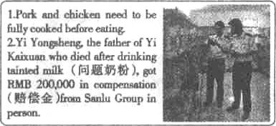
选择 阅读下列材料，．从A、B、C三个选项中．选出最佳选项回答问题。
46. From the information, we can know something about .
A. traffic safety
B. food safety
C. Internet safety

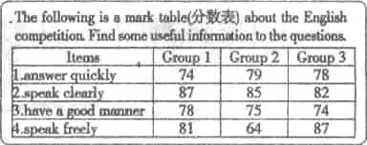
47. speak dearly beet of all the groups.
A. The students in Group 1
B. The students in Group 2
C. The students in Group 3

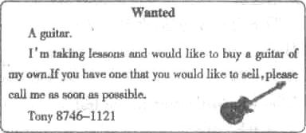
48. Who would call Tony?
A. One who knows how to play the guitar.
B. One who wants to give him lessons,
C. One who wants to sell his guitar.

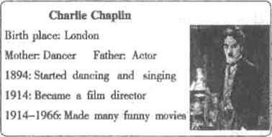
49. What kind of movies did Charlie Chaplin make?
A. Thrillers.
B．Action movies.
C. Comedies.

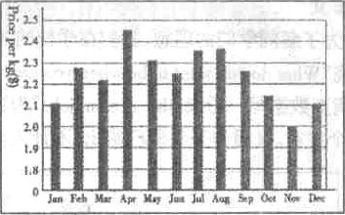
50. It is a chart about the price of rice last year. Do you think which seasons were good to sell rice?
A. Spring and summer
B. Spring and autumn
C. Summer and autumn

(C)
匹配 阅读下篇材料，从所给的A-F六个选项中，选出五个正确的选项填空，使短文通
顺、内客完整。
Anger is a kind of feeling 51 . When your teacher gives you too much homework, when your team loses an important game, when a friend borrows your favorite thing and then breaks it, you may get angry.
52 . For example, you breathe faster, your face turns red, and you may want to break something or hit someone, but sometimes you hide your anger. For example, you may hide it in your heart. The problem is that if you do this, you may get a headache or your stomach may hurt.
In fact, it's not good to hide your anger, and it's normal for you to get angry sometimes. 53 . When you get angry, you can talk about it with adults such as parents, teachers, etc. 54 . Here are some other things you can do when you start to feel angry: count from 1 to 100; give someone a hug; go for a bike ride; think about good things, etc.
Remember that when you are angry, how you act can make everything better or
worse. 55 .
A. But anger must be let out in the right way, without hurting others or yourself．
B．Don’t let your anger control you．
C. As soon you can find your problems, you may cry to relax．
D．Usually, your body will tell you when you are angry．
E. After doing that, you’ll find those bad feelings can start to go away．
F. Many things can make you angry．

(D)
阅读填空 根据下面短文内容，在短文的空格处填上一个恰当的词．使短文完整、通顺。
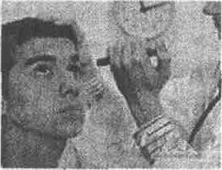
Our eyes are very important to us. They are like cameras. We can see beautiful things and colors around us.
56 our eyes. But if we don't take care of them, they may
hurt. 57 do we protect our eyes?
On sunny days, the sun shines brightly. So we'd better
58 our sunglasses. When we read, we shouldn't stay
too close to our books and the light shouldn't be too bright 59 too dark. We mustn't read in bed. It’s 60 for our eyes. We mustn't rub our eyes with dirty hands or play games on computer too long.
(E)
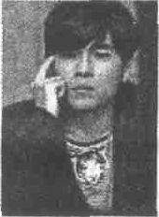
回答问题 阅读短文，然后推据短文内容．简要回答下列问题。
Have you seen the videos on TV? Do you wear large T-skirts and
baggy jeans? Or have you heard someone rap(说唱)? Hip-Hop is very
hot now.
Hip-Hop music was started in the middle of the 1970s by African Americans in New York. The music, break-dancing(霹雳舞) and graffiti (涂鸦) make up Western Hip-Hop culture. Most of the
Hip-Hop songs are about love, jobs or even games.
Usually in rap, singers speak words very quickly to a certain beat. Most of the words are fun. Singers play off words to make fun of themselves or others. Hip-Hop music has few rules. Singers just do what they think and rap it out in a clever or creative(创造性的)way. It makes a lot of teenagers fall in love with the music. Many of them like wearing large T-shirts and baggy jeans. Famous rap and Hip-Hop stars include Eminem in the US. and Jay Chou from China.
Today Hip-Hop is more and more popular across most of the world.
61. Is Hip-Hop very hot now?
62. When was Hip-Hop music started?
63. What are most of the Hip-Hop songs about?
64. Does Hip-Hop have many rules or few rules?
65. Why do a lot of teenagers fall in love with the music?
Ⅳ.写作技能(共三郜分，11小题,每个部分l0分：共30分)
A）翻译语篇 阅读下面的短文．将文中划线部分的句子做相应的英、汉互译。
The students were having their chemistry class. 66. Miss Li was telling the students what water was like. After that, she asked her students, "What's water?" No one answered. A few minutes later, Miss Li asked again, “67. 你们为什么不回答我的问题? Didn't I tell you what water was like? ”
Just then a student put up his hand and said, "Miss Li, you told us that water has no color and no smell. However, where to find such kind of water? The water in the river behind my house is always black, and it has a bad smell" 68.大多数学生同意他的意见。
“I'm sorry, children?” said the teacher, 69. "Our water is getting dirtier and dirtier.
That's a problem. 70. We should do what we can to make the world cleaner."
66．
67.
68.
69.
70.
B)完成对话 通读下面的对话．然后根据上下文补全对话内容。
Gina: Hi, Mary. Your skirt is so beautiful.
Mary: Thank you very muck
G: 71 ?
M: I bought it in Yunnan.
G: Yunnan? Oh, you are so hcky.72 ?
M: Yes, I went there last summer. I had a good time.
G: 73 ?
M: It was sunny and warm. I visited many beautiful places.
G: 74 ?
M: The people there are very friendly and kind.
G: I hope to visit it one day.
M: I'm sure you'll love it.
G: I think I will. Oh, I'm afraid I must go now, See you.
M: 75 .
C)作文
76．为了解同学们的理想，我们在学校的l00名学生中进行了一次调查采访。采访主要是围绕“What do you want to be when you grow up?”和“Why?”这两个问题进行的，请你根据以下调查数据写—份以“the dream jobs”为主题的报告．并谈谈你自己的理想与原因。词数80个左右。(报告开头语已给出．不计人作文总词数。)
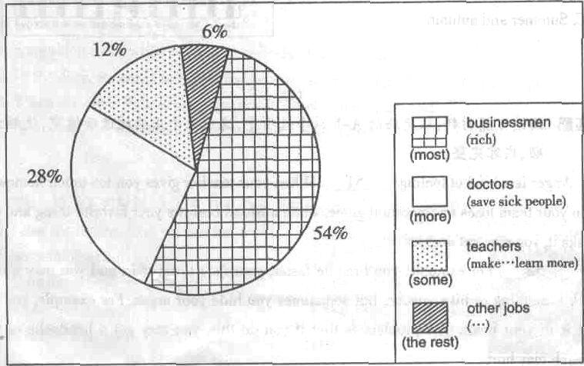
The Dream Jobs
In order to help us form good ideals (理想), we made a survey among 100 students in our school. Here are the results.



