南昌市卷与江西省卷大部分试题相同，有个别试题不同，请注意区分
江西省南昌市201 1年中等学校招生考试
英语试题卷
说明：1．本卷分为试题卷和答题卷，答案请写在答题卷上，不要在试题卷上作答，否则不给分。
2．本卷共有5大题、86小题，全卷满分120分，考试时间为120分钟。
一、听力测试(25分)
现在是试听时间。请听一段对话，然后回答问题。
What is the boy going to buy?
A．Some juice． B．Some oranges． C．Some apples．
答案是C。
A)请听下面5段对话。每段对话后有一小题，从题中所给的A、B、C三个选项中选出最佳选项，并在答题卷上将该项涂黑。听完每段对话后，你都将有10秒钟的时间回答有关小题和阅读下一小题。每段对话读两遍。(每小题1分)
1. What does the woman want to do?
A. To go for a walk. B. To watch TV. C. To go to a movie.
2. What's the man's telephone number?
A. 8521639. B. 8513269. C. 8532619.
3. How's the weather in London tomorrow?
A. Rainy. B. Snowy. C. Windy.
4. Why is the girl late?
A. Because she had to do her homework at home.
B. Because she visited her grandma this morning.
C. Because she had to stay with her grandma at home.
5. What does the woman mean?
A. The man phoned the dentist earlier before that.
B. The man may not see the dentist right now.
C. She is sorry that she is too busy to help him.
B)请听下面3段对话和2段独白。每段对话或独白后有几个小题，从题中所给的A、B、C三个选项中选出最佳选项，并在答题卷上将该项涂黑。听每段对话或独自前你都将有30秒钟的时间阅读各小题：每段对话或独自读两遍。(每小题1分)
请听第1段对话．回答第6至第7小题。
6. What would the man like to eat?
A. Noodles. B. Dumplings. C. Hamburgers.
7. Why didn't the man eat breakfast?
A. Because he got up too late this morning.
B. Because his aunt didn't make it for him.
C. Because he was not feeling well this morning.
请听第2段对话．回答第8至第l0小题。
8. Where did the woman go two months ago?
A. Paris. B. New York. C. Sydney.
9. How did the woman go there?
A. By train. B. By car. C. By plane.
10. How long did the woman stay in Disneyland?
A. For two days. B. For three days. C. For four days.
请听第3段对话。回答第11至第l3小题。
11. When does the boy want to see a movie?
A. This Friday. B. This Saturday. C. This Sunday.
12. Which movie can the boy watch?
A. The Sound of Music. B. My Father's Birthday. C. Black September.
13. What can we get from this conversation?
A. The tickets are 15 dollars each.
B. The movie starts at 8:00 in the morning.
C'. The boy thinks the tickets are too expensive.
请听第1段独白。回答第14至第l6小题。
14. Where does this monologue (独白) probably happen?
A. At a bus stop. B. In a car. C. In a classroom.
15. Who saved the driver's life?
A. His best friend. B. The old lady. C. The young woman.
16. How many people are there in the story?
A. 3. B. 4. C. 5.
请听第2段独白，回答第17至第20小题。
17. Where was the picture taken?
A. At my birthday party.
B. At my mum's birthday party.
C. At my sister's birthday party.
18. Who is an engineer?
A. My father. B. My mother. C. Uncle Simon.
19. What is Aunt Liz good at ?
A. Speaking Chinese. B. Singing. C. Playing the piano.
20. Which of the following is true?
A. My father can play football.
B. My uncle is 45 years old.
C. My parents are at the front of the picture.
C)请听下面一段短文，根据短文内容完成表格，每个空格不超过3个单词。将答案填写到答题卷的相应位置。听短文前你将有50秒钟的时间阅读表格内容。短文读两遍。(每小题1分)
Welcome to our party!
Time to start: 21. at ______________ tonight
Place: 22. in the school_______________
For whom: 23.________________________
Things to bring: 24.________________________
Activities: 25. listening to songs,__________________
二、语言知识运用(30分)
A)单项填空 请阅读下面各小题，从题中所给的A、B、C、D四个选项中选出可以填入空白处的最佳选项．并在答题卷上将该项涂黑。(每小题1分)
26. Come on,_________________ you'll be late.
A. and B. but C. or D. so
27. I can't eat any more food, I am_________________.
A. busy B. hungry C. full D. serious
28. I hated my new school at first, but I made lots of friends and now I _________ it.
A. get B. take C. fit D. love
29. --Where did you go for your winter vacation?
--My family went to Paris. ________ had a great time.
A. He B. She C. We D. They
30. I've decided to go to London next weekend. I was wondering ______ you could go
with me.
A. if B. when C. that D. where
31. The work is too hard for him. He _______ finish it on time.
A. can't B. mustn't C. shouldn't D. needn't
32. --Can I help you?
--________________ . I want to buy some T-shirts for my children.
A. Yes, please B. No, thanks C. It doesn't matter D. Of course I can
33. Mary isn't here at the moment. She _______ later.
A. comes B. came C. has come D. is coming
34. --Would you like to play basketball with us this afternoon?
-- ______________ . I have to study for tomorrow's test.
A. I'd love to B. I'm afraid not C. Sounds good D. No problem
35. Harriet is lost and her parents are really _______ her.
A. interested in B. afraid of C. busy with D. worried about
36. I'm now in New York with my friend Jenny. We ______ by plane on Monday.
A. arrive B. arrived C. are arriving D. will arrive
37. The doctor told me to eat more _______ because it's good for my health.
A. orange B. vegetables C. ice cream D. fish
38. How kind you are! You always do what you can_________ me.
A. help B. helping C. to help D. helps
39. --We're doing a lot to protect our environment, but it is not good enough.
--So we should try ______ to look after it.
A. hard B. harder C. hardest D. hardly
40. --What happened to Billy?
--He __ because of his drink-driving.
A. is caught B. was caught C. has caught D. had caught
B)短语填空。请阅读下面各小题，从方框中选择适当的短语填空，并在答题卷上将其序号涂黑。每个短语限用一次。(每小题1分)

A. show up B.came up with C. Thanks to D. turn down E. At first
F. by mistake G. make progress H.depend on I. Strict with J. As for
41.My sister Jenny _______ a great idea!We’re going to make a yard sale.
42.You’d better not ask Jane to go out at night. Her parents are very ________her.
43. What the people ther wear should _______ their likes and dislikes.
44. The baby is sleeping. Could you ________the music, please?
45.I am not good at my lessons. I hope I can _______ next term.
46. ——I’m afraid this is my umbralla.
—— Sorry, I took yours ___________.
47. Do you know where Mike is? He should be here an hour ago but he didn’t ______.
48. _________the policy, great changes have taken place in Nanchang.
49. ________I thought he was shy, but then I discovered he was just not interested in other people.
50. __________the hotel, it is very comfortable and quite close to the sea.
C)补全对话。请阅读下面对话，从方框内7个选项中选择5个恰当的句子完成对话，并在答题卷上将其序号涂黑。其中有两个句子是多余的。(每小题1分)
Lisa: Hi,Jo. How is it going?
Jo: Terrible.
A. It’s not the end of the world.
B.Do you need any help?
C. Cheer up!
D. What’s wrong?
E. That sounds interesting.
F.Tell me all about it.
G..I can’t believe that!

Lisa:51. ____________________
Jo: I’m worrried about my math test result.
Lisa: 52._____________________________
Jo: I did badly in my test and my dad always gets angry when I get bad grades.
Lisa: 53. _______________ Isn’t he easy-going?
Jo: Not really. I don’t know what will happen.
Lisa: 54._______________________
Jo:I know. But you don’t know my dad.
Lisa: 55.______________ Let’s go shopping.
Jo: Ok. Let’s go.
三、完形填空(25分)
A)请先阅读下面短文，掌握其大意，然后从各小题所给的A、B、C、D四个选项中选出可以填人相应空白处的最佳选项．并在答题卷上将该项涂黑．(每小颢1分)
It Seemed Like a Good Idea at the Time
I really only meant it as a joke. I wasn't trying to steal anything honestly.
My friend Matthew started bringing his new cell phone to class last week. He was walking around bragging (吹嘘) about it to everyone. He was saying, "My cell phone can download (下载) the newest games off the internet." Then he 56 everyone by downloading a game and starting to play it. The pictures and sound were really 57 .
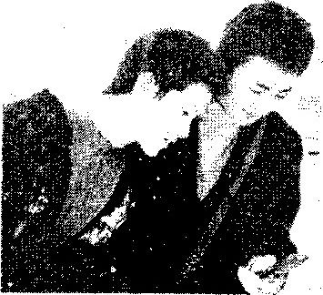
After class, he would use his cell phone to watch TV.
The test of us didn't have a phone like his, so we had to crowd around him. I was just trying to see the screen, 58 there were so many other kids that I could not see it clearly. I was getting really jealous (嫉妒).
But then yesterday, he forgot his cell phone at the end of class. He left it right on his desk. 59 noticed it was there except me. I decided to teach him a lesson. I took his phone quietly off the desk, and put it in my own bag. My 60 was to give it back to him the next day. I 61 wanted to see his reaction (反应). Maybe he would stop being such a show-off.
But this morning he rushed into class, screaming and yelling (吼叫). He was very 62 and almost mad. He started accusing (指责) different people of stealing his phone, but I had it in my 63 the whole time. He even started fighting with another classmate 64 Matthew was sure that person had taken it. The teacher sent them to the headmaster's office. They both got in a lot of trouble. Now I don't know what to 65 ! If I tell him that I took the cell phone, he'll think I stole it. If I don't tell him, then I really did steal it. How did I get into such a trouble?
56. A. gave B. showed C. lent D. asked
57. A. good B. bad C. noisy D. unclear
58. A. and B. but C. then D. so
59. A. Everybody B. Somebody C. Anybody D. Nobody
60. A. plan B. suggestion C. dream D. action
61. A. always B. hardly C. just D. sometimes
62. A. happy B. quiet C. sad D. angry
63. A. desk B. hand C. bag D. pocket
64. A. if B. because C. until D. though
65. A. say B. take C. see D. do
B)请先阅读下面短文，掌握其大意，然后从方框内所给的词中选出最恰当的l0个，用其适当形式填空，并将答案填写到答题卷的相应位置。每个词限用一次。(每小题1分)
so start easy badly someone difficult
if thank class reporter medical succeed

Proving Them Wrong!
I'm John Wood, a doctor at a famous Boston hospital. During the first two years of high school, I found biology very 66 . My report cards always said things like "must study harder" or "John shouldn't choose science 67 ." It was really terrible for 68 who had always dreamed of becoming a doctor. I lost confidence, so I left high school at sixteen and 69 working at a supermarket.
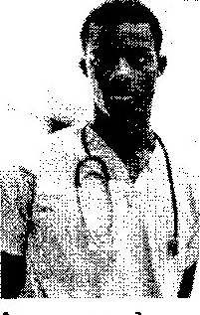
One evening I saw a documentary about Albert Einstein. According to the documentary, Einstein had done really 70 at school. I began to think that if Einstein could 71 , then 1 may have a chance, too. I didn’t want to leave my job, 72 I decided to go to night school to finish high school. Two years later, I went to a 73 university.

I've often thought I should contact (联系) the 74 from the Einstein documentary and 75 him. As for the biology teacher, I might contact her, too, one day - but not to thank her!
四、阅读理解(40分)
A）请阅读下面短文，根据短文内容从每小题所给的A、B、C、D四个选项中选出最佳选项，并在答题卷上将该项涂黑。(每小题2分)
A
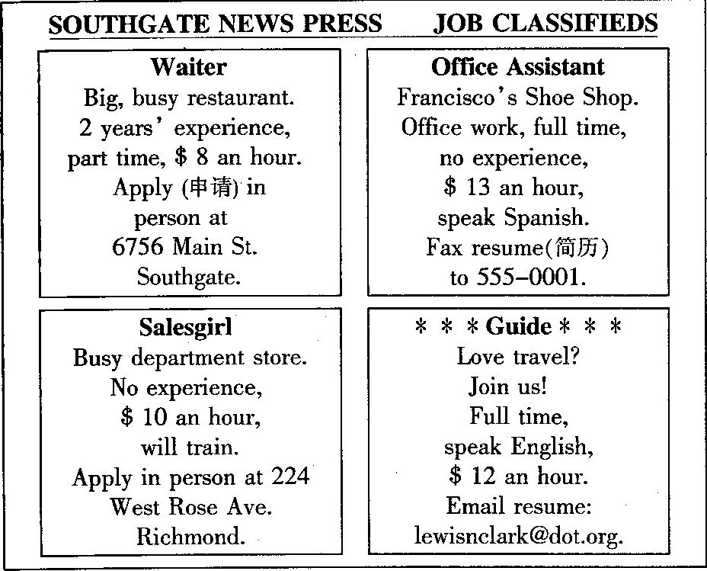
76. If you want to find a job as a waiter, you can _________ to apply for it.
A. go to 6756 Main St. Southgate B. go to 224 West Rose Ave. Richmond
C. fax resume to 555-0001 D. email resume: lewisnclark@dot.org
77. If you do office work at Francisco's Shoe Shop, you should_____________.
A. be trained B. have experience
C. speak English D. know Spanish
78. If you work as a guide, you can get __ an hour.
A.$ 8 B. $ 10 C. $ 12 D. $ 13

B
Welcome to the Amazing kids Website! Here you can read about clever children all over the world.
Gina, who is thirteen years old, got first prize in the "Young Cook of the Year" competition and is now writing her own recipe (烹饪) book for kids. "I want it to be fun to read and easy enough for children to use," she says. Gina learned by observing (观察) her father, who's also good at cooking, in the kitchen. She wants to encourage other children to cook because "everyone needs to eat, so it's a skill that will always be useful! "
Fourteen-year-old Bren used to love running until he had a serious car accident three years ago. He lost part of one leg and didn't even expect to walk again. Now he's an athlete who has recently completed a marathon. "After my accident I wanted to give up," he says. "But now I'm happy to be alive and able to continue running."
Helga has always been good at science, but she thought it was too difficult to become an inventor. Then she heard about an accident that had happened when a car hit a train in her town. "That gave me an idea," says the clever sixteen-year-old girl. It took her over a year to invent a special machine that tells car drivers when a train is coming.
One company is already interested in selling it, so it may be in the shops soon!
79. How is Gina trying to encourage other children to cook?
A. By observing her father.
B. By writing a recipe book for kids.
C. By giving them delicious food to eat.
D. By getting first prize in the competition.
80. Which of the following is true about Helga?
A. She saw a car hit a train in her town.
B. She sold special machines to car drivers .
C. She invented a special machine for car drivers.
D. It is impossible for her to become an inventor.
81. Which would be the best title for the passage?
A. Amazing Kids, Special Abilities B. How to Be a Good Student
C. Different People, Different Ideas D. How to Get Living Skills

C

Doctors Without Borders (国界)
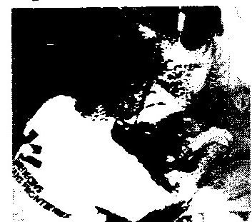
Chris is not a traditional explorer(探险家) -- he usually works in an office for a large organization. However, Chris' job can be just as exciting and dangerous as being an explorer.
Chris works for MSF, an organization also known as .Doctors Without Borders. Since1971, MSF has sent trained doctors all over the world to help people who have suffered from disasters (遭受灾难), such as wars and illnesses. Chris is a doctor from France who has traveled to many places to organize programs that help people.

At the moment, over 27,000 trained doctors have taken part in MSF projects. The organization received the Nobel Peace Prize in 1999. All kinds of doctors can volunteer for MSF. They need to be ready to go almost anywhere in the world and, of course, they should face difficulties. Most of MSF's work is in Africa. When MSF chooses a doctor for a task, they have to go for at least six months. When doctors have completed a few tasks, they might be sent on an emergency (紧急的) task following a disaster, such as an earthquake.
But why would doctors leave a comfortable life and a good pay to join MSF? According to Chris, the experience they have is a great help in their life. What's more, just like the explorers of the past, they need to keep an open mind and learn to get on well with the people they meet. One thing that they can say at the end of any task is that they have made a real difference to people’s lives.
82. What may MSF's work be like?
A. Tiring and boring. B. Exciting and dangerous.
C. Relaxing and colorful. D. Peaceful and comfortable.
83. As a volunteer doctor for MSF, he or she should______.
A. have worked in Africa for six months
B. have been sent on an emergency task
C. be ready to work for a task for at least half a year
D. have suffered from wars, illnesses or other disasters
84. Why would doctors like to join MSF?
A. Because they can get a good pay.
B. Because they can have a comfortable life.
C. Because they can help others and get experience.
D. Because they can travel abroad with their families.
85. What is the main idea of this passage?
A. Chris is a doctor who has organized programs to help people.
B. MSF received the Nobel Peace Prize for helping poor countries.
C. Volunteer doctors make a real difference to their own lives in MSF.
D. MSF offers medical help to people who have suffered from disasters.
B)请阅读下面短文。根据短文内容从下面方框内的七个选项中，选择五个还原到文中，使短文意思通顺、结构完整，并在答题卷上将其序号涂黑。（每小题2分）
86. ______ It has around 3 billion fans - nearly half the world's population! And about 300 million people play this game. That's 4 percent of the world' s population!
87. ______ Many people in old days played early forms (形式) of this modern game. Cu ju (蹴鞠), a ball-kicking game in China, was reported as early as 2,500 B.C. Around the same time in Greece, people were also playing a similar ball game without using their hands.
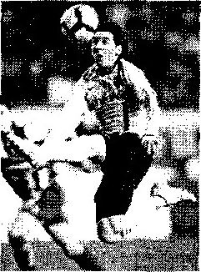
But modern soccer didn't become official (官方的) until 1863. An Englishman called Cobb Morley introduced the idea of a soccer association (联盟). 88. _______ From then on, other associations in the countries were set up. They came together-to make up the FIFA, which organizes the World Cup.
It's not easy to tell what makes soccer so popular. 89. ______ Soccer needs only two feet and a ball. This makes it a sport that developing countries can easily play. Some of the sport' s best players come from these poor nations.
90. _____ The sport's no-hands rule makes beautiful dance-like movements on the field. What's more, this sport excites the heart. Teams might score only a few times each match, so matches can turn around suddenly.
No one knows who will win at the next World Cup. But one thing is certain: The world will be watching.
A. He also wrote the sport's official rules.
B. Soccer is the world's favorite sport.
C. Playing soccer is good for your health.
D. But one reason is how simple the sport is.
E. People love soccer as well as their countries.
F. It's hard to say where soccer's birthplace is.
G. Soccer performances are pleasing to the eyes.

机密．2011年6月19日
江西省201 1年中等学校招生考试
英语听力材料
试听材料：
M: I'm going shopping, Mum. Do you need anything?
W: Yes, get some apples and some oranges to make juice with.
M: Well, we already have lots of oranges.
W: OK, just some apples then.
答案是C。
A)请听下面5段对话。每段对话后有一小题，从题中所给的A、B、C三个选项中选出最佳 选项．并在答题卷上将该项涂黑。听完每段对话后，你都将有10秒钟的时间回答有关小题和阅读下一小,题。每段对话读两遍。
1. W: Hello! Kevin! What are you doing now?
M: Not much. Do you have any plans?
W: I want to take a walk.
2. M: Hello, may I speak to Mary, please?
W: Sorry, she's out at the moment. Can I take a message?
M: Thanks. Please ask her to call me back. My telephone number is 8-5-1-3-2-6-9.
W: 8513269, right?
M: That's right.
3. M: We're going to London tomorrow.
W: Will it be snowy?
M: You must be kidding! It may not even be cold, just wet. The weather report says it will be windy.
4. M: Hey, Sally. You're late. The museum is closed.
W: Sorry,. My grandma visited us this morning, so I stayed at home and talked with her.
M: That's OK.
5. M: Oh, please. I have to see the dentist right now. I have a terrible toothache.
W: Sorry, he is busy now. Let me see, have you phoned before?
M: Sorry, I haven't.
B)请听下面3段对话和2段独白。每段对话或独自后有几个小题，从题中所给的A、B、C三个选项中选出最佳选项．并在答题卷上将该项涂黑。听每段对话或独自前你都将有30秒钟的时间阅读各小题。每段对话或独自读两遍。
请听第1段对话。回答第6至第7小题。
W: Hi, Jason, How are you?
M: I'm hungry.
W: I can bring you some food. What would you like?
M: Noodles, please.
W: I' 11 go and get some for you. Did you eat breakfast?
M: No.
W: Why didn't you eat breakfast?
M: My aunt was not at home. She didn't make breakfast for me.
请昕第2段对话．回答第8至第l0小题。
W: What are you going to do on holiday, Tony?
M: We're going to Sydney.
W: You'll love it! I went there two months ago. We had a great time.
M: How long did it take to get there?
W: It took about 12 hours.
M: And who was with you?
W: My aunt and uncle met me at the airport.
M: And where did you go?
W: Well, first, we went to Disneyland.
M: How long did you spend there?
W: We spent two days there. And then we went shopping.
请听第3段对话．回答第11至第l3小题。
W: Hello, People's Cinema. Can I help you?
M: Hello, I'm phoning about tickets for this Saturday,
W: Which movie would you like to watch?
M: Have you got tickets for "My Father's Birthday"?
W: Sorry. There aren't any tickets left for it.
M: What about " The Sound of Music"?
W: Oh, yes. We have some tickets.
M: Oh, right. What time does the movie start?
W: It starts at eight o'clock in the evening.
M: OK. How much do the tickets cost?
W: They're 50 dollars each.
M: 50 dollars?! Can I phone back later? I'll ask my mum.
W: Oh, that's OK.
请听第1段独白，回答第14至第l6小题。
Hello, boys and girls. Now I'm going to tell you a story. You need to listen carefully, because I've got a problem about the story for you to discuss. Are you ready? .-- OK.
A man is driving home late at night. It's raining and it's very cold. At a bus stop he sees three people waiting for a bus. The first person is his best friend. This friend once saved his life. The second person is an old lady. She's very ill and needs to go to hospital. The third person is a young woman. The man loves this woman very much. The man wants to help all the three people but he can only take one person in his car. What should he do?
I'll give you 5 minutes to have a discussion in groups of four. After discussion, please
tell us your answer and tell us why
请听第2段独白。回答第17至第20小题。
Hello! Everyone! Let me show you a nice picture.
This is my family at my mum's birthday party last year. These are my parents. My father is ,12, and he's an engineer. He rides a horse very well. My mother is a nurse. She is 38. She works very hard. Uncle Simon is behind my parents. He's 45 years old and he's a doctor at a hospital. He can play football. My aunt Liz is next to Uncle Simon. She's my mum's sister. She's 31 years old. She's a music teacher. She plays the piano very well and she can speak a little Chinese.
My sister and I are in front of my parents. We are both students.
That's all. Thanks a lot!
C)请听下面一段短文，根据短文内容完成表格，每个空格不超过3个单词。将答案填写到
答题卷的相应位置=听短文前你将有50秒钟的时间阅读表格内容。短文读两遍。(每小题1分)
Good morning, here is Sunshine High School on the radio. There's a wonderful party in our school meeting room tonight. It starts at 7:30. It's for our foreign teacher —MrGreen. He has been teaching here for 2 years. He teaches so well that everyone likes him. But he's going back to London next week. So we'll have to say goodbye to him. To show our thanks, everyone can bring a small present for him. The Beach Boys will play all their new songs. They're our favorite band. Everyone will dance to the music. We'll be enjoying ourselves here. Come and join us! See you at 7:30 tonight.



